

**APPLIED PHYSICS LAB REPORT # 4**

**SUBMITTED BY:**

* MUHAMMAD ATTIQ UR REHMAN
* MUHAMMAD HASSAM
* ASHFAQ AHMAD
* ZIA UL ISLAM
* ABDUL RAHEEM

**SUBMITTED TO:**

SIR HASEEN ULLAH JAN

**DCSE/// SECTION # B**

**#UETPESHAWAR**

**TITLE:**

DETERMINE THE HIGH RESISTANCE BY METHOD OF LEAKAGE.

**APPARATUS:**

* BALLASTIC GALVANOMETER
* THREE KEYS
* HIGH RESISTANCE BOX
* CELL
* CAPACITOR
* STOP WATCH.

**PROCEDURE:**

1. Make the electrical connections
2. Close K1 and press the Morse key I;e charge the condenser for 40 sec
3. Release the Morse key K2 so that the condenser is discharged through the galvanometer. Note down the first throw $θ .$
4. Repeat the procedure several times I;e every time charge condenser and then discharge through the B.G obtained mean value of $θ.$
5. Closing the key K1 and pressing K2 charge the condenser for the same time. Keeping Morse key pressed, open key K1 and start the stop watch.
6. After measuring the time t sec release the Morse Key and note down the first throw $θ\left(t\right)$ in the galvanometer.
7. Repeat the procedure for different values of t.

**DIAGRAM:**

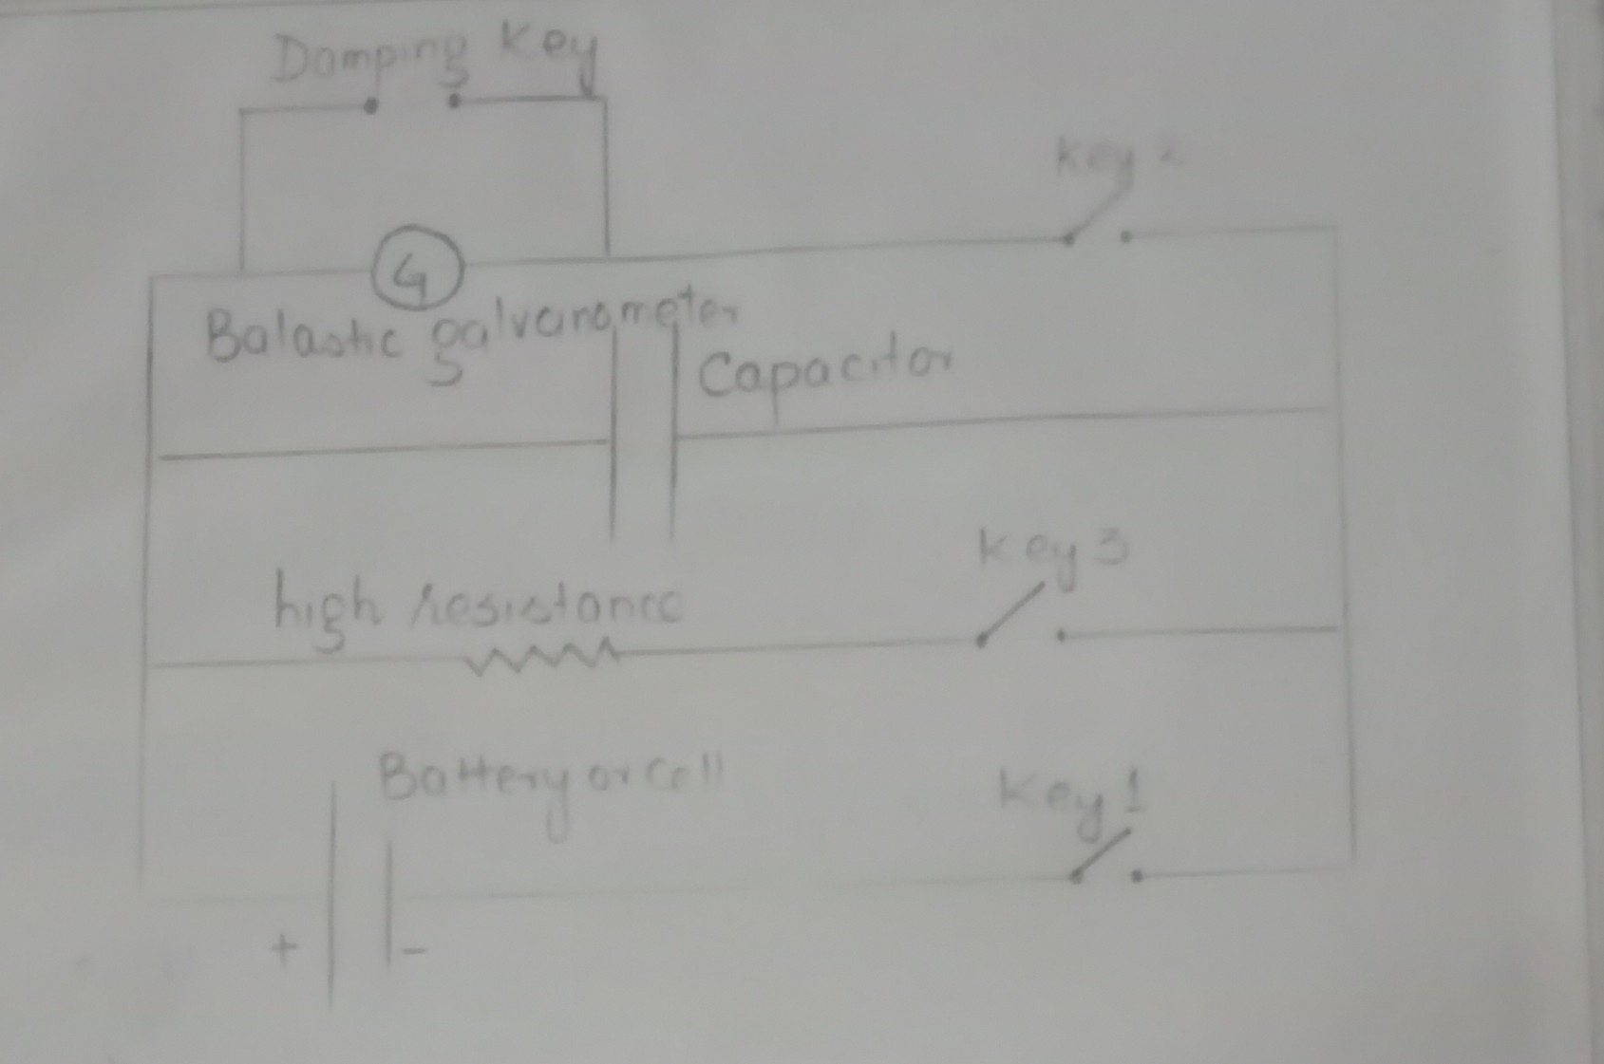

**OBSERVATIONS:**

|  |  |  |  |
| --- | --- | --- | --- |
| $$θ$$ | **Θ(t)** | **t** | **R** |
| 80 | 50 | 4 | 8.51*106Ω |
| 58 | 45 | 3 | 11*106Ω |
| 59 | 46 | 2.12 | 8.54*106Ω |

**PRECAUTIONS:**

* The galvanometer coil should be made properly free.
* Tapping key should be used across the galvanometer.
* After observing $θ$, the galvanometer coil should be at rest for observing the value of θt.

**THE END**